**[SPE1053L]**

**NEWCASTLE UNIVERSITY**

**_________________**

**SEMESTER 2 2018/19**

**_________________**

**LINGUISTICS AND PHONETICS I:**

**LINGUISTICS**

**Time allowed: One hour (60 minutes)**

**Instructions to candidates:**

1. Answer **ALL** **SIX** questions, which are equally weighted.
2. There are pages for rough work at the end of this exam paper. These **must** be handed in.

**Student Identification Number:** (no names please, so that texts can be blind marked)

**___________________ MARK: _______%**

**(1) Word classes and functions**

For these sentences

(a) label all of the syntactic functions

(b) label all of the functions and word classes

EXAMPLE

The big grey mare nuzzled the tottering foal

FUNCTIONS: | **S** | **V** | **Od** |

WORD CLASSES: **D Adj Adj N v D Adj N**

NB all words must belong to a syntactic function. You could use vertical lines as above, or a horizontal line, e.g.

The big grey mare

--------------S----------------

A list of functions and word classes are provided at the end of this booklet (please feel to detach the pages)

a) Geoff was punished by his parents last night

---S--- ---------V---------- --------A-------------- ------A-------

N Aux v P det/Pron N det N

*"By his parents" is not a classic Adverbial as it cannot be moved. However, it is an optional element, which is not an argument, and therefore best described as an Adverbial.*

*"Last" behaves like a determiner. Distributionally it comes in place of other determiners, e.g. "during last night I felt unwell / during the night I felt unwell". (However if I were to say "the last house on the left" it would be an adjective).*

b) The teacher awarded him an extra star for his fantastic essay

*-*------S--------- -----V----- -Oi- -------Od---------- ---------------A-------------------

Det N v P Det Adj N P Det Adj N

c) For Pete’s sake stop playing that music so loud !

-------------A----------- ---------V-------- -------Od------ ------A-----

P N gen N v v Det N Adv Adj

*"So loud" is a funny kind of Adverbial as it cannot be moved. But it is nonetheless optional. It is not moveable because it attaches low down in the tree. "So" could also be labelled "Int" for intensifier*

d) The poor depressed servant cried herself to sleep

--------------------S----------------------- --V-- --Od--- ----Co-----

Det Adj Adj N v Pron P N

*NB "to sleep" is an Object Complement, modifying "herself"*

**(2) Dependent (subordinate) clauses.**

(i) For each sentence, draw a line under the dependent clause(s).

(ii) For each dependent clause, write a brief description of the role/function of that dependent clause. For clauses which are complements (**Od, Oi, Cs, Co**), which word are they the complement of? For modifying clauses (**A and PMod**), what do they modify?

(iii) Put a box around subordinating words, and a circle around coordinating words.

Examples

Jack was surprised when he heard the news

Adverbial Clause modifying main clause (“jack was surprised”)

It was angry that he lost my wallet

Clause is complement of adjective “angry”

(a) Jack is always on for a party as long as there is copious booze

Adverbial clause modifying main clause

(b) I was really surprised that he didn’t turn up for the exam

Clause is complement of adjective "surprised"

(c) I prefer the house that has the stained glass windows

Relative clause, postmodifying "house"

(d) Whilst eating a hummus sandwich he suddenly realised his crown had fallen out

Adverbial clause, modifying main clause Clause is direct of object of verb

"he suddenly realised…" "realised"

(e) Because the fish he bought smelt slightly off he took it back to the fishmonger’s.

Adverbial clause modifying main clause

"he took it back…"

relative clause postmodifying "the fish"

(f) Angelito proposed that until Jorge moved out they should share the household chores

Clause is the direct of object of "proposed"

Adverbial clause modifying higher-level clause "they should share…"

**(3) Labelling tense, aspect and voice**

For each of the following sentences, label the tense, grammatical aspect and voice.

*Possible tenses*: Present, past, “future”, NONE

*Possible grammatical aspects*: Progressive, Perfective, Progressive Perfective, NONE.

*Possible voices*: Active, passive.

|  |  |
| --- | --- |
| (1) They won’t have finished interviewing yet | Tense: "Future"  Aspect: Perfect (or "perfective")  Voice: Active |
| (2) So much had been written about that terrible event | Tense: Past  Aspect: Perfect (or "perfective")  Voice: Passive ("…had been written by hedgehogs") |
| (3) The roof of the house was being repaired | Tense: Past ("was")  Aspect: Progressive ("being")  Voice: Passive ("…being repaired by hedgehogs!") |
| (4) Stop being so silly! | Tense: NONE ("stop" is non-finite, and so is "being")  Aspect: Progressive ("being")  Voice: Active |
| (5) You’ll be laughing all the way to the bank | Tense: "Future" ("will")  Aspect: Progressive ("laughing")  Voice: Active |
| (6) She’d been studying Latin for over five years | Tense: Past ("She had been…")  Aspect: Perfect ("been") Progressive ("studying")  Voice: Active |
| (7) What’s your opinion about the incident? | Tense: Present ("is")  Aspect: NONE  Voice: Active |
| (8) Dinner is served. | Tense: Present ("is")  Aspect: NONE  Voice: Passive ("Dinner is served by hedgehogs") |

**(4) Psycholinguistic data / models**

In the exam there will be a choice between two questions. This practice exam only contains one (so I don’t run out of good questions to ask!). There are three lectures this semester focused on psycholinguistic topics: the two lectures on language processing (comprehension) in Weeks 8 and 9, and the lecture on Linguistics in the clinic (week 10). The week 9 lecture on formulaic language also discusses a psycholinguistic model of the relationship between formulaic and productive processes.

INSTRUCTIONS: Choose **one** of the following two questions. Write an answer of about 100 words (half a page)

(a) What do we mean by the “parser”? To what extent does it work in a bottom-up fashion?

(b) _ _ _ _ _ _ _ _ _ _ _ _ _ _ _ __ _ _ _ _ _ _ __ _ _ _ _ _ _ __ _ _ _ _ _ _ __ _ _ _ _ _ _ _

*Page for writing answer*

Below is an ideal answer, but a student would not be expected to write all of this under exam conditions.

IDEAL ANSWER

(1) Give a definition of a parser.

e.g. It is a cognitive mechanism which deals with the **real-time analysis of sentence structure**.

(2) Give definition of bottom up and top down

e.g. **"bottom up" processing makes decisions on the basis of the immediate input**. A bottom up parser makes rapid decisions about structure based on possible word classes of incoming words. Once a word has been recognised, we look up the word in our mental dictionaries, determine possible word classes, and choose the most appropriate word class based on our knowledge of syntactic frames. For instance, if we hear "the" and then the word "dog" this will trigger the frame "DET + NOUN" as "dog" is a potential Noun. **"top down" processing makes decisions on the basis of "higher level" information**, e.g. world knowledge, or information about how we use certain words in sentences. For example, if we hear "the man saw the woman with the basket" our encyclopaedic knowledge tells us that the basket can't be the instrument of seeing (high attachment interpretation), and must therefore be an object possessed by the woman

(3) Briefly mention evidence for either the bottom up or top down view, and conclude that both must be at work. For bottom-up effects you could refer to classic garden path effects, e.g. a tendency to keep the clause open - "Since Jay always jogs a mile and a half seems a long way to him". The fact we are garden-pathed so easily suggests that the parser is operating according to a special procedure (heuristic). For top down processing you could refer to Trueswell, 1993, study (see Lecture) whereby we made predictions about sentence structure on the basis of the verb (top-down influence of lexical information).

**(5) Clinical materials / data**

Look at the following picture prompts which belong to standardised assessments. Write an ideal response (ie what sentence does the child need to produce, or what picture do they need to point to). Then describe the “linguistic ability” that is being assessed?

When describing the “linguistic ability” try to use linguistic terminology which has been introduced in the lectures, and refer to specific word classes or constructions you have come across, e.g. “the ability to use prepositions”, “the ability to use the Verb Phrase”, or “the ability to use the superlative construction”.

Answers should be between one and three sentences long depending on what abilities are being measured

NB there are two items for you to practice. The actual exam will have **four**.

*1. Mummy wants to know if the boy has brushed his teeth, so what does she say?*

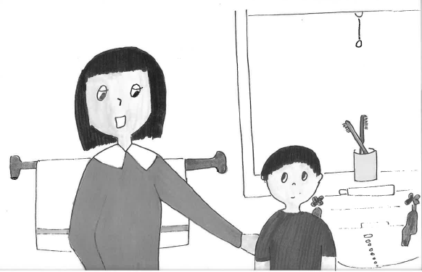

TARGET RESPONSE: Have you brushed your teeth?

WHAT LINGUISTIC ABILITIES ARE BEING ASSESSED? A number of different grammatical abilities are assessed by this question: use of the PRESENT PERFECT ("have" + PAST PARTICIPLE) to describe a past event with present relevance, ability to use auxiliary "have", ability to use a past participle ("brushed"), ability to make a question by inverting the auxiliary ("Have you brushed _ your teeth?). The key thing I am looking for is the **inversion**. Any response referring to the auxiliary and mentioning that it moved used to form a question will get full points. A response referring to other aspects of the response, e.g. use present perfect, will get half points.

*2. The girl is being pushed by the boy*

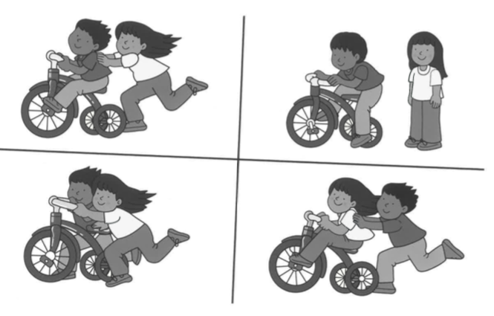

TARGET RESPONSE: Bottom-left picture

WHAT LINGUISTIC ABILITIES ARE BEING ASSESSED? The question tests comprehension of the passive. Any response mentioning the passive will get full marks. Any response mentioning tense/aspect only (it is present progressive) will get half marks.

**(6) Mini essay**

Write about 50 - 150 words (half a side to a side) on **one** of the following topics. If you run out of time you can make notes. High marks will be given if your notes contain relevant content.

The topics will all be from semester 2

In order not to run out of good essay titles, I have included only one in this practice exam.

(a) What do we mean by “mood” and how is it manifested in terms of sentence structure?

*Page for writing answer*

Below is an ideal answer, but a student would not be expected to write all of this under exam conditions.

The term "mood" describes our "attitude" to the sentence we are talking about. In English there are four main moods, **declarative**, **interrogative** (questions), **imperative** (commands), and **exclamative**. The moods have particular syntactic features. English declaratives describe situations / events and have a simple Subject-Verb-Complement word order, e.g.

Jack likes cheese

S V Od

Annie is nice

S V Cs

Interrogatives, which are used to ask questions, are formed using certain grammatical processes, e.g. "Wh"-movement (movement of questioned constituent to the front of the sentence), and auxiliary-movement or do-support (non-subject questions), e.g.

**Whati arej** you _j reading _i ?

Imperatives, which are used to make requests, or commands, drop the subject and use an infinitive form, e.g.

(You) come here!

Exclamatives, which are used to describe extreme or noteworthy situations, have a similar structure to questions and can also involve movement of an auxiliary verb,

e.g. Boy **is** he _ angry!

*Page for writing answer*

*Page for writing answer*

*Page for writing answer*

*Page for writing answer*

*Page for writing answer*

*Page for writing answer (THIS IS THE FINAL PAGE)*

**LABELS**

(Please detach this sheet if you wish, but hand in at the end of the exam)

Labels for syntactic functions:

S: Subject

Od: Direct Object

Oi: Indirect Object

Cs: Subject Complement

Co: Object Complement

A: Adverbial

Labels for word classes

Open class:

N: Noun

v: Main or lexical verb

Inf: Used to mark an infinitive verb, e.g. *to go*.

Adj: Adjective

Comp: Comparative Adjective or Adverb

Int: Intensifier, e.g. *very* good.

Closed-class

D: Determiner

Pr: Preposition

Pron: Pronoun

Aux: auxiliary verb, e.g. *have done.*

Cop: Copula (verb *to be* used as the main verb)

Neg: Negative particle

Part: Verb particle, e.g. put *down*.

gen: Anglo-saxon genitive ‘s

Dummy elements

It: Dummy *it,* e.g. ***it****’s raining*

There: Dummy *there*, e.g. ***there****’s a party on Tuesday*

Combining clauses

c: Coordinator (*and, but*)

s: Subordinator (e.g. *although, because*)